VISVESVARAYA TECHNOLOGICAL UNIVERSITY
JNANA SANGAMA, BELGAVI-590018

A Project Report on
Smart Attendance System: using Face Detection and RFID Integration
submitted in partial fulfilment of the requirements for the award of the Degree of
Bachelor of Engineering
in
Computer Science and Engineering
Submitted by
ABHISHEK H [1DB21CS002]
ADEEB AHMED [1DB21CS005]
BALAJI M [1DB21CS021]
DHANU KUMAR T N [1DB21CS034]

Under the Guidance of
Dr. Venugeetha Y

Professor

Department of Computer Science & Engineering
Don Bosco Institute of Technology
Kumbalagodu, Mysore Road, Bengaluru-560 074
2024 - 2025
VISVESVARAYA TECHNOLOGICAL UNIVERSITY
DON BOSCO INSTITUTE OF TECHNOLOGY
Kumbalagodu, Mysore Road, Bengaluru-560 074
DEPARTMENT OF COMPUTER SCIENCE AND ENGINEERING


CERTIFICATE

This is to certify that the Project Work entitled “Smart Attendance System: using Face Detection and RFID Integration” has been carried out by ABHISHEK H (1DB21CS002), ADEEB AHMED (1DB21CS005), BALAJI M (1DB21CS021) and DHANU KUMAR T N (1DB21CS034) the bonafide students of the Don Bosco Institute of Technology, Bengaluru, in the partial fulfilment for award of Degree of Bachelor of Engineering in Computer Science and Engineering of Visvesvaraya Technological University, Belagavi, during the academic year 2024–2025. This Project Work has been approved as it satisfies the academic requirements for the award of the Bachelor of Engineering Degree.

________________ ____________________ __________________
Signature of Guide Signature of HOD Signature of Principal
Dr. Venugeetha Y Dr. K B ShivaKumar Dr. B S Nagabhushana
Professor, Professor and Head, Principal,
Dept. of CSE, Dept. of CSE, DBIT, Bengaluru
DBIT, Bengaluru DBIT,Bengaluru

External Viva:
Name of the Examiner Signature with Date
1)__________________ ___________________
2)__________________ ___________________
ACKNOWLEDGEMENT

The satisfaction and euphoria that successful completion of any project is incomplete without the mention of people who made it possible, whose constant guidance and encouragement made our effort fruitful.

First and foremost, we ought to pay our due regards to this institute, which provided us a platform and gave an opportunity to display our skills through the project work. We express our heartfelt thanks to our beloved principal Dr. B S NAGABHUSHANA, Don Bosco Institute of Technology, Bangalore for his encouragement and providing us with the infrastructure.

We express our deep sense of gratitude and thanks to Dr. K B SHIVAKUMAR, Head of the Department, Computer Science and Engineering for extending his valuable insight and suggestions offered during the course.

We express our acknowledgement to our project coordinator Dr. ASHA K H, Associate Professor, Dept. of CSE for extending their direction and support during the completion of Project.

It is our utmost pleasure to acknowledge the kind help extended by our guide Dr. VENUGEETHA Y, Professor, Department of Computer Science and Engineering, for guidance and assistance which consequently resulted in getting the project work completed successfully.

Last but not the least I would like to thank teaching and non-teaching staff for their cooperation extended during the completion of the project.

Abhishek H [1DB21CS002]
Adeeb Ahmed [1DB21CS005]
Balaji M [1DB21CS021]
Dhanu Kumar T N [1DB21CS034]

DON BOSCO INSTITUTE OF TECHNOLOGY
Kumbalagodu, Mysore Road, Bengaluru-560 074
DEPARTMENT OF COMPUTER SCIENCE AND ENGINEERING


DECLARATION

We, ABHISHEK H (1DB21CS002), ADEEB AHMED (1DB21CS005), BALAJI M (1DB21CS021) and DHANU KUMAR T N (1DB21CS034) students of seventh semester Computer Science and Engineering, Don Bosco Institute of Technology, Bangalore, declare that the Project Work entitled, “Smart Attendance System: using Face Detection and RFID Integration” has been carried out by us and submitted in partial fulfilment of the course requirements for the award of degree in Bachelor of Engineering in Computer Science and Engineering of Visvesvaraya Technological University, Belagavi during the academic year 2024-2025. The matter embodied in this report has not been submitted to any other university or institution for the award of any other degree.

Place : Bengaluru
Date:

ABISHEK H 1DB21CS002
ADEEB AHMED 1DB21CS005
BALAJI M 1DB21CS021
DHANU KUMAR T N 1DB21CS034

ABSTRACT

Effective attendance management is essential yet difficult in contemporary organisations. For smooth and precise attendance tracking, the "Smart Attendance System" integrates facial detection and RFID (Radio Frequency Identification), utilising cutting-edge technology. Real-time validation is ensured by this technology, which uses facial recognition to record and confirm individual identities using Machine Learning models. By using embedded RFID tags to track and register attendance, RFID technology simultaneously adds another level of accuracy. Reducing human intervention, removing manual errors, and increasing efficiency are the goals of the process. Through the integration of these technologies, the suggested system guarantees efficient, dependable, and expandable attendance management, meeting a range of institutional requirements while preserving data integrity and minimal latency throughout operations.

TABLE OF CONTENTS

ACKNOWLEDGEMENT | I
DECLARATION | II
ABSTRACT | III
TABLE OF CONTENTS | IV
LIST OF FIGURES | V

CHAPTER & TITLE | PAGE NO.
Chapter 1 : INTRODUCTION  - Existing System  - Proposed System  - Objective  - Problem Statement  - Hardware Requirements  - Software Requirements | 1-5  1  2  2  3  3  4
Chapter 2 : LITERATURE SURVEY | 6-7
Chapter 3 : SYSTEM DESIGN  3.1 System Architecture  3.2 Methodology  3.3 Source Codes  3.4 Sequence Diagram  3.5 Use Case Diagram | 8-22  8  9  11  20  21
Chapter 4 : IMPLEMENTATION AND RESULTS | 23-26
Chapter 5 : CONCLUSION | 27
REFERENCE | 28
APPENDIX | 29

LIST OF FIGURES

FIGURE NO. | TITLE | PAGE NO.
3.1 | RFID-based system flow | 8
3.2 | Sequential Representation of the working project | 20
3.3 | The student's face was successfully detected | 21
3.4 | The student's RFID card was successfully scanned | 22
4.1 | User registration interface | 23
4.2 | User login interface | 24
4.3 | Main dashboard interface | 24
4.4 | Student management system dashboard | 25
4.5 | Face detection successful | 25
4.6 | RFID scanning successful | 26
4.7 | Recording Attendance in Excel | 26

Smart Attendance System: using Face Detection and RFID Integration

CHAPTER 1
INTRODUCTION
Reliable and effective systems are now essential for handling daily chores in the era of rapid technology innovation. Punch cards and human roll calls are two examples of traditional attendance control techniques that are time-consuming, prone to mistakes, and susceptible to fraud. These difficulties show that in order to increase dependability and streamline attendance tracking, accurate, current methods are required.

Existing solutions are insufficient to fulfil the demands of modern contexts because they lack automation, real-time tracking, and strong authentication procedures. Their inefficiencies highlight the need for a cutting-edge strategy that guarantees security, accuracy, and scalability. Innovative solutions that smoothly incorporate cutting-edge technology into everyday operations are needed to address these inadequacies. [5]

By fusing radio-frequency identification (RFID) and facial recognition, the RFID-enhanced Automated Face Recognition Attendance System provides a complete solution. Python's programming capabilities enable real-time video feed analysis for facial recognition, which enables contactless, precise tracking. By connecting facial information with RFID credentials, RFID provides an additional layer of authentication, guaranteeing increased dependability even in difficult situations. By addressing the drawbacks of conventional systems, this dual-layer strategy offers a scalable, secure, and user-friendly solution that meets contemporary demands.

  - EXISTING SYSTEM
RFID and face recognition technologies are combined in the current Smart Attendance System with Face Detection and RFID Integration to provide safe and precise attendance tracking. In order to register, users must scan their RFID cards and provide their facial information, which is then utilised for authentication when attendance is recorded. By offering dual-layer verification, the technology lowers the likelihood of proxy attendance while maintaining security. Real-time attendance data is captured and saved for later use.

The system has a number of shortcomings in spite of its advantages. The accuracy of face detection can be impacted by external factors like bad illumination, low-quality cameras, or physical barriers like masks or spectacles. Internal considerations include the dependability of the facial recognition and RFID technologies as well as the effectiveness of the software algorithms. The system may generate false positives or incorrectly authenticate users if the program contains errors or flaws. RFID cards may also be susceptible to wear and tear, which could cause delays in scanning or read failures. Additionally, the system needs top-notch technology for both facial recognition and RFID scanning, which raises expenses and maintenance needs. Strict adherence to data protection laws is necessary because to privacy concerns about the handling and storage of private face information.

  - PROPOSED SYSTEM
The shortcomings of the current system are addressed by the suggested Smart Attendance System with Face Detection and RFID Integration, which combines better hardware and sophisticated algorithms to increase security and accuracy. To increase identification accuracy in low light and get around problems like facial obstructions, the system makes use of better cameras and more advanced face recognition algorithms. Along with a fail-safe feature that advises users to rescan if necessary, it incorporates more dependable software to lower the likelihood of false positives and scanning errors. [1] [5]
Furthermore, the suggested approach improves privacy by processing and storing sensitive data using more robust encryption methods, guaranteeing adherence to privacy laws. The system provides alternate approaches, like mobile-based RFID access, which enables users to authenticate using cell phones, to address the issue of RFID card wear and tear. Additionally, the system is made to work with a greater variety of hardware, which lessens reliance on pricey devices and increases its affordability. Overall, by increasing accuracy, decreasing hardware dependence, and guaranteeing smooth user experiences, the suggested system offers a more dependable, secure, and user-friendly solution.
  - OBJECTIVE
- Develop a Reliable and Efficient Attendance System
- Create an automated system to accurately record attendance using facial recognition technology combined with RFID authentication, eliminating the need for manual processes.
- Implement advanced facial recognition algorithms and RFID readers to ensure high accuracy and reduce the time required to mark attendance.
- Enable real-time processing of video feeds for face detection and RFID card scanning, ensuring immediate attendance marking.

- Integrate with a Robust Database and Provide a User-friendly Interface
- Utilize MySQL to securely store and manage user data, RFID credentials, and attendance records, ensuring data integrity and efficient retrieval.
- Design an intuitive interface for administrators and users to facilitate easy registration, management of attendance records, and seamless system operation.
- Implement a fully contactless and hybrid solution (facial recognition and RFID), promoting hygiene and safety standards.

  - PROBLEM STATEMENT
Traditional attendance management systems, such as manual roll calls and punch cards, are inherently flawed due to their susceptibility to errors, time consumption, and potential for fraudulent activities. These systems often require significant human effort and oversight, leading to inefficiencies and inaccuracies in maintaining attendance records. Moreover, reliance on a single method, such as facial recognition, can face challenges under specific conditions, such as poor lighting or occlusions.

The integration of RFID technology with facial recognition offers a robust solution to address these shortcomings. By combining these technologies, the system ensures high accuracy, enhanced security, and adaptability to various environments, providing a reliable alternative to traditional methods.

  - HARDWARE REQUIREMENTS
  - Processor: Intel(R) Core (TM) i7-8550U CPU @ 1.80GHz
The Intel Core i7-8550U processor would be used to power the Smart Attendance System by handling real-time face detection and recognition using Python libraries like OpenCV, as well as processing RFID authentication. Its multi-core capability enables smooth video feed analysis for facial recognition, while its efficiency ensures optimal performance for database operations in MySQL. The processor’s power efficiency also supports continuous system operation without excessive heat or battery drain, making it ideal for deployment in an attendance management system.
  - RAM: 8.00 GB
8GB RAM is used to efficiently run the Smart Attendance System, enabling smooth real-time face detection and RFID authentication. It allows seamless multitasking between video processing, database operations (MySQL), and RFID scanning without performance lags. The RAM ensures quick data retrieval, enhances system responsiveness, and supports the simultaneous execution of Python-based facial recognition algorithms and RFID validation processes.
  - Hard Disk: 50 GB
50GB Hard Disk storage is used to store the Smart Attendance System's essential data, including facial recognition models, RFID credentials, user information, and attendance records in the MySQL database. It also accommodates the Python libraries (OpenCV, face-recognition), application files, and logs, ensuring smooth operation and sufficient space for system updates and data expansion over time.
Components:
- Camera (for facial data capture) – Captures real-time video feeds for facial recognition, enabling contactless and accurate attendance marking.
- Arduino UNO (to interface with RFID scanners) – Acts as a microcontroller to read data from RFID scanners and communicate with the system for authentication.
- RFID Cards and Scanner – RFID cards store unique identification data, and the scanner reads this data to verify user identity alongside facial recognition.
- Jumper Wires – Used to establish electrical connections between the Arduino, RFID scanner, and other components for seamless data transmission.

  - SOFTWARE REQUIREMENTS
  - Operating System: Windows 11
Windows 11 provides a stable and user-friendly environment to run the Smart Attendance System, ensuring compatibility with Python, MySQL, and hardware drivers (camera, RFID scanner). It supports smooth multitasking and execution of facial recognition and database operations.
  - Programming Language: Python 3.12
Python 3.12 is chosen for its simplicity, efficiency, and extensive library support. It allows seamless integration of facial recognition and database operations while ensuring real-time processing of video feeds and RFID authentication.
  - Libraries: OpenCV, Face-recognition, MySQL Connector
  - OpenCV – Used for real-time face detection and recognition, processing video feeds from the camera.
  - Face-recognition – A Python library built on dlib, used for precise facial recognition to verify user identity.
  - MySQL Connector – Connects the Python application with MySQL, allowing efficient storage and retrieval of attendance records, user details, and RFID data.
  - Database: MySQL
MySQL serves as the central database to store user profiles, facial data, RFID credentials, and attendance records. It ensures fast querying, secure data management, and structured storage, allowing easy retrieval and analysis of attendance data when needed.

CHAPTER 2
LITERATURE SURVEY
[1] Keerthana Sanath, Meenakshi K, Muktha Rajan, Varshini Balamurugan, and M.E. Harikumar, “RFID and Face Recognition based Smart Attendance System”, Fifth International Conference on Computing Methodologies and Communication (ICCMC 2021), IEEE Xplore Part Number: CFP21K25-ART.
Temperature checks are incorporated into a smart attendance system that uses RFID and facial recognition to guarantee health and safety. The technology tracks user moods and uses facial recognition and RFID validation to keep an eye on wellbeing. This system's improved security, health monitoring capabilities, and emotion recognition for user welfare are its main advantages. The system's reliance on external elements, such as illumination, and the high processing requirements for facial and emotion detection tasks are drawbacks, though.

[2] Bing-Zhong Ji ng, Patrick P. K. Chan, Wing W. Y. Ng, and Daniel S. Yeung, “Anti-Spoofing System for RFID Access Control Combining with Face Recognition”, Ninth International Conference on Machine Learning and Cybernetics, Qingdao, 11-14 July 2010 @ IEEE.
By utilising Adaboost face detection and optical flow algorithms to verify that the identified face is authentic, an anti-spoofing system for RFID access control coupled with face recognition enhances security. With a 100% rejection rate for spoofing efforts and a 99% success rate in authorising actual users, this system showed excellent dependability. Despite its efficiency, the system is computationally costly and needs particular environmental factors, including sufficient lighting, to function at its best.

[3] Uppanapalli Lakshmi Sowjanya and R. Krithiga, “Facial Emotion Detection Model Using CNNs and Uniform Local Binary Pattern (uLBP) to analyze student behavior”, IEEE Access, Vol. 12, 2024.
A Facial Emotion Detection Model Using CNNs and Uniform Local Binary Pattern (uLBP) analyzes student behavior, achieving 94% accuracy in detecting emotions and providing real-time insights to educators for dynamic teaching adjustments. While the system offers high accuracy and practical applications, it faces challenges related to computational complexity, the need for large datasets for training, and variations in emotional recognition, particularly in cross-cultural contexts.
[4] Dae-Hee Seo, Jang-Mi Baek and Mi-Yeon Yoon, “Improved Authentication Scheme using Facial Recognition scheme based on RFID Tag”, 2010 International Conference on Multimedia Information Networking and Security, Nanjing, China, 17 December 2010 @IEEE.
Recently diverse studies have emerged on the ubiquitous environment including the ones on RFID tag. In terms of security, in particular, RFID tag is not able to provide complex forms of security services due to its hardware limits, putting in turn limits on its wider use. Therefore, this thesis is to suggest an improved RFID tag authentication scheme using face recognition scheme. It divides passive RFID tags and active ones, provides secure device authentication using the hash function based on the passive RFID tag, and offers user authentication using 2D face recognition data, thus providing an improved form of RFID authentication scheme.

[5] Mingtao Zhao , Gang Zhao , and Meihong Qu, “College Smart Classroom Attendance Management System Based on Internet of Things”, Hindawi, Computational Intelligence and Neuroscience, Volume 2022, Article ID 4953721
This article introduces a smart classroom attendance system using RFID and face recognition technologies within an IoT framework. The RFID system efficiently detects absences and substitutions but is affected by obstructions, requiring students to place identification cards uniformly. The face recognition system tracks attendance, tardiness, and early departures, though its accuracy can be influenced by lighting, posture, and facial expressions. Despite these limitations, both systems offer innovative solutions for modernizing attendance management.

[6] Narayana Darapaneni, Aruna Kumari Evoori and Dhivakar Babu, “Automatic Face Detection and Recognition for Attendance Maintenance”, 15th (IEEE) International Conference on Industrial and Information Systems (ICIIS), 2020.
This paper focuses on building a deep learning-based efficient attendance capturing system. Instead of traditional attendance methods, the authors propose automating it by identifying human faces with their unique features using Face Recognition. The system utilizes face detection (a prerequisite for face recognition) to identify and locate faces regardless of position, scale, orientation, lighting, or expression. The authors created a system using YOLO, MTCNN, and FaceNet embeddings, incorporating augmentations, image quality checks, and de-noising methods. This approach aims to create a better attendance system with less maintenance, low-cost hardware (Google Colab), and improved performance and accuracy.
CHAPTER 3
SYSTEM DESIGN
Key components are included in the RFID-enhanced Automated Face Recognition Attendance System to provide effective operation. Still images of people are taken by a camera and processed by facial recognition software. A secondary layer of authentication is offered via RFID readers and cards, guaranteeing precise attendance and identity confirmation. While the backend incorporates RFID data for user verification, Python manages image processing and facial recognition. Administrators may control the system using an easy-to-use interface, and a database holds user data and attendance logs. This system is ideal for educational institutions because it was created with scalability, usability, and security in mind.

3.1 SYSTEM ARCHITECTURE
The flow of the system design is illustrated in the following picture, showcasing the use of RFID technology for automated attendance tracking. It demonstrates the process of capturing RFID data, verifying identity, and updating attendance records in real-time.
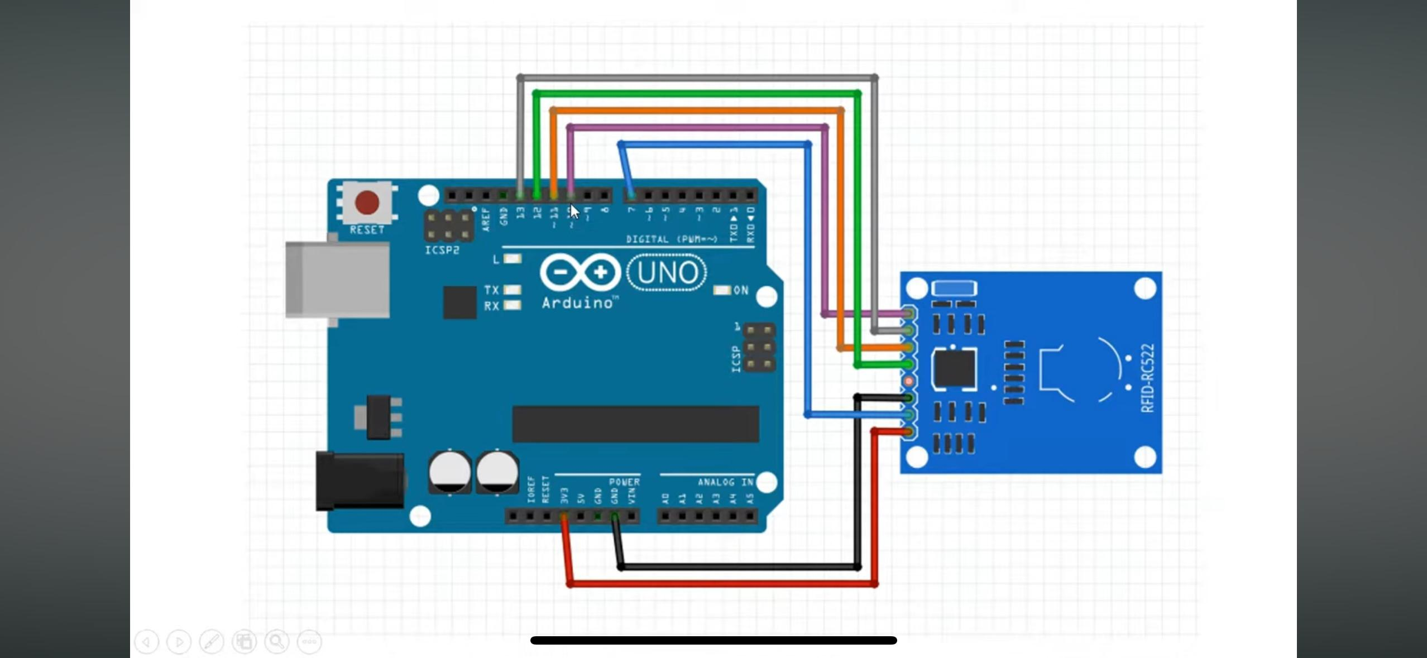
Fig 3.1: RFID-based system flow
Figure 3.1 depicts a basic RFID access control system using an Arduino Uno microcontroller and an RFID-RC522 reader module. The Arduino, acting as the system's brain, communicates with the RFID module via SPI (Serial Peripheral Interface) to read unique identification numbers (UIDs) from RFID tags or cards. When a valid UID is detected, the Arduino can then trigger actions, such as granting access by activating a relay or logging the event. The connections shown illustrate the SPI communication lines (MOSI, MISO, SCK, SS) and power supply for the RFID module.
Architecture:
  - Input Layer: Camera captures real-time facial images, and RFID scanner reads the card.
  - Processing Layer: Facial recognition algorithms match facial data, and RFID credentials are verified against the database.
  - Storage Layer: Attendance records, facial data, and RFID information are securely stored in MySQL.
  - Output Layer: Attendance status is displayed on the interface in Excel.

3.2 METHODOLOGY
The RFID and facial recognition-based system's technique combines software and hardware elements in a methodical way to accomplish smooth attendance tracking. In order to ensure safe and effective operation, this section describes the process flow from data collection to verification and final output.
1. Input Layer Data Capture
Facial Data Capture: When people approach the RFID scanner, the device uses a camera to take real-time pictures of their faces. The processing unit receives the collected image from the camera and analyses it.
RFID Card Scanning: The RFID scanner reads the user's card in addition to their facial information. The system receives the distinct ID linked to the RFID card for validation.

2. Data Processing
Facial Recognition: Python libraries like OpenCV and face-recognition are used to process the recorded facial image. To identify the person, facial features are taken out of the picture and matched to the information that has been stored. Machine Learning models are used by the facial recognition algorithm to guarantee precision and reduce mistakes.
RFID Authentication: The system compares the user database kept in MySQL with the RFID card ID. The user is authenticated if the card ID is legitimate. The technology confirms the person's identification for attendance if face recognition and RFID authentication match.

3. Storage Layer for Data
Database management: A MySQL database safely stores RFID information, attendance records, and facial data. Important information like user IDs, facial recognition, RFID card IDs, and attendance records are stored in the database.
Data Security: To preserve security and privacy, the system makes sure that all data, including private RFID information and sensitive facial photos, is kept in an encrypted format in the MySQL database.

4. Reporting and Output
Attendance Logging: The system instantly updates the attendance record upon a successful authentication. For ease of inspection and reporting, the user's status—whether present or absent—is recorded in an Excel sheet.
User Interface: Administrators can examine and monitor the attendance data by using the user interface, which shows the attendance status. It is simple to export the Excel report for administrative purposes or to create comprehensive attendance reports.

5. Operational Flow
Step 1: Presenting their RFID card, the user walks up to the system.
Step 2: The system uses the camera to take a picture of the user's face.
Step 3: Data from the RFID card is read and the facial image is processed.
Step 4: The system checks the RFID card against the database by comparing the facial data with stored photos.
Step 5: The attendance is recorded as "present" and entered into the database if the RFID and facial data match.
Step 6: The Excel sheet is updated with the attendance data for examination and analysis.
6. Safety Procedures
Authentication Process: Only authorised users are able to indicate attendance thanks to the dual-layer authentication system (facial recognition + RFID), which offers a better level of protection.
Data Integrity: To prevent fraudulent attendance marking, it is crucial to guarantee the correctness and integrity of both facial and RFID data.

7. Error Management and Enhancement
Error Handling: The system prompts the user to try the process again by generating an error message if either RFID authentication or facial recognition fails.
Optimisation: The system minimises delays in facial recognition and RFID card scanning by processing data efficiently utilising Python modules. Additionally, a dependable processor and enough RAM guarantee seamless functioning.

3.3 SOURCE CODE
1. Code to Recognize Facial Data
A camera is used to take pictures of faces, which are then processed using Haar Cascade for face detection and identified by an LBPH recogniser. Details like name and department are displayed once recognised faces are compared to a database. Faces that are not recognised are labelled as "Unknown," guaranteeing quick and safe identification.

Main.py
def face_recognition(self):
def draw_boundary(img, classifier, scaleFactor, minNeighbors, color, text, clf):
def preprocess_image(img):
"""Preprocess the image to improve face detection."""
img = cv2.cvtColor(img, cv2.COLOR_BGR2GRAY) # Convert to grayscale
img = cv2.equalizeHist(img) # Enhance contrast using histogram equalization
return img

# Preprocess the input image
gray_image = preprocess_image(img)

# Detect faces in the image
features = classifier.detectMultiScale(gray_image, scaleFactor=1.05, minNeighbors=5)
coord = []

for (x, y, w, h) in features:
cv2.rectangle(img, (x, y), (x + w, y + h), color, 3)
id, predict = clf.predict(gray_image[y:y + h, x:x + w])
confidence = int((100 * (1 - predict / 300)))

# Database connection for face data retrieval
conn = mysql.connector.connect(
host="localhost", username="root", password="0000", database="face_atd"
)
my_cur = conn.cursor()
my_cur.execute("SELECT Name FROM student WHERE sid=%s", (id,))
name = "+".join(my_cur.fetchone() or ["Unknown"])
my_cur.execute("SELECT usn FROM student WHERE sid=%s", (id,))
usn = "+".join(my_cur.fetchone() or ["Unknown"])

my_cur.execute("SELECT Dept FROM student WHERE sid=%s", (id,))
dept = "+".join(my_cur.fetchone() or ["Unknown"])

my_cur.execute("SELECT sid FROM student WHERE sid=%s", (id,))
sid = "+".join(my_cur.fetchone() or ["Unknown"])

conn.close()

if confidence > 77:
# Display details on the video feed
cv2.putText(img, f"USN: {usn}", (x, y - 55), cv2.FONT_HERSHEY_COMPLEX, 0.8, (255, 255, 255), 3)
cv2.putText(img, f"Name: {name}", (x, y - 30), cv2.FONT_HERSHEY_COMPLEX, 0.8, (255, 255, 255), 3)
cv2.putText(img, f"Dept: {dept}", (x, y - 5), cv2.FONT_HERSHEY_COMPLEX, 0.8, (255, 255, 255), 3)
self.mark_att(usn, name, dept, sid)
else:
cv2.rectangle(img, (x, y), (x + w, y + h), (0, 0, 255), 3)
cv2.putText(img, "Unknown", (x, y - 55), cv2.FONT_HERSHEY_COMPLEX, 0.8, (255, 255, 255), 3)

coord = [x, y, w, h]
return coord

def recognize(img, clf, faceCascade):
# Recognize faces and draw boundaries
coord = draw_boundary(img, faceCascade, 1.1, 10, (255, 25, 255), "Face", clf)
return img
# Load the Haar Cascade Classifier and Face Recognizer
faceCascade = cv2.CascadeClassifier("haarcascade_frontalface_default.xml")
clf = cv2.face.LBPHFaceRecognizer_create(radius=2, neighbors=16, grid_x=8, grid_y=8)
clf.read("classifier.xml")

# Capture video feed from webcam
vid_cap = cv2.VideoCapture(0)
while True:
ret, img = vid_cap.read()
img = recognize(img, clf, faceCascade)
cv2.imshow("Face Recognition", img)
if cv2.waitKey(1) == ord('q'): # Exit on pressing 'q'
break

vid_cap.release()
cv2.destroyAllWindows()

2. Code to Recognize RFID Cards
By reading the unique IDs (UIDs) of RFID cards and comparing them to predetermined UIDs, this application detects and identifies RFID cards using the MFRC522 RFID module. When a valid card is detected, it uses serial communication to record attendance information, including name and USN, to an Excel page. LEDs and a buzzer are used to offer feedback. To ensure safe and effective attendance tracking, invalid cards cause a red LED to illuminate.

RFID_Excel.ino
#include <SPI.h>
#include <MFRC522.h>
#define SS_PIN 10 // RX slave select
#define RST_PIN 9

MFRC522 mfrc522(SS_PIN, RST_PIN); // Create MFRC522 instance.

byte card_ID[4]; // card UID size 4 bytes
byte TagUID[4] = {0x43, 0xC9, 0xAD, 0xFA}; // RFID tag UID
byte Card1UID[4] = {0xC3, 0xB4, 0x04, 0x2F}; // First card UID
byte Card2UID[4] = {0xB3, 0x92, 0x04, 0x2F}; // Second card UID
byte Card3UID[4] = {0x53, 0xDA, 0x33, 0x1C}; // Third card UID
byte Card4UID[4] = {0x73, 0x32, 0x35, 0x1C}; // Fourth card UID
byte Card5UID[4] = {0x03, 0xF1, 0xFB, 0x2E}; // Fifth card UID
byte Card6UID[4] = {0xA2,0x7C,0x33,0x1D}; // Fourth card UID
byte Card7UID[4] = {0x43,0x8C,0x03,0xBE}; // Fifth card UID

int DetectedCards[8] = {0, 0, 0, 0,0,0, 0, 0}; // Array to track detected cards (index 0: Tag, index 1-5: Cards)
int cardIndex = -1;

int const RedLed = 8;
int const GreenLed = 5;
int const Buzzer = 8;

String Name; // Card holder name
String USN; // USN of the card holder
long Number; // Optional: User number
void setup() {
Serial.begin(9600); // Initialize serial communication
SPI.begin(); // Init SPI bus
mfrc522.PCD_Init(); // Init MFRC522 card

Serial.println("CLEARSHEET"); // Clear the Excel sheet starting at row 1
Serial.println("LABEL,Date,Time,Name,USN,Number"); // Add labels for the Excel columns

pinMode(RedLed, OUTPUT);
pinMode(GreenLed, OUTPUT);
pinMode(Buzzer, OUTPUT);
}

void loop() {
// Look for a new card
if (!mfrc522.PICC_IsNewCardPresent()) {
return; // Go to the start of the loop if no card is present
}
// Select one of the cards
if (!mfrc522.PICC_ReadCardSerial()) {
return; // If unable to read the card, restart loop
}

// Copy the UID of the detected card
for (byte i = 0; i < mfrc522.uid.size; i++) {
card_ID[i] = mfrc522.uid.uidByte[i];
}

// Check which card was scanned and assign details
if (compareUID(card_ID, TagUID)) {
cardIndex = 0;
Name = "Master Tag (Admin)";
USN = "N/A";
Number = 1001;
} else if (compareUID(card_ID, Card1UID)) {
cardIndex = 1;
Name = "ABHISHEK H";
USN = "1DB21CS001";
Number = 1001;
} else if (compareUID(card_ID, Card2UID)) {
cardIndex = 2;
Name = "ADEEB AHMED";
USN = "1DB21CS005";
Number = 1002;
} else if (compareUID(card_ID, Card3UID)) {
cardIndex = 3;
Name = "BALAJI M";
USN = "1DB21CS021";
Number = 1003;
} else if (compareUID(card_ID, Card4UID)) {
cardIndex = 4;
Name = "DHANU KUMAR T.N";
USN = "1DB21CS034";
Number = 1004;
} else if (compareUID(card_ID, Card5UID)) {
cardIndex = 5;
Name = "Unkown";
USN = "N/A";
Number = 1111;
} else if (compareUID(card_ID, Card6UID)) {
cardIndex = 6;
Name = "Ashwin R";
USN = "1DB21CS017";
Number = 11110;
} else if (compareUID(card_ID, Card7UID)) {
cardIndex = 7;
Name = "Sagar";
USN = "1DB21CS047";
Number = 11111;
} else {
// Invalid card UID
digitalWrite(RedLed, HIGH);
delay(1000);
digitalWrite(RedLed, LOW);
return;
}

// Check if the card has already been detected
if (DetectedCards[cardIndex] == 1) {
// If already detected, do nothing
return;
} else {
// Mark the card as detected
DetectedCards[cardIndex] = 1;
// Send data to Excel
Serial.print("DATA,DATE,TIME," + Name + "," + USN + ",");
Serial.println(Number);

// Turn on Green LED and buzzer for success
digitalWrite(GreenLed, HIGH);
digitalWrite(Buzzer, HIGH);
delay(100);
digitalWrite(Buzzer, LOW);
delay(900);
digitalWrite(GreenLed, LOW);
}
}

// Function to compare two UIDs
bool compareUID(byte *a, byte *b) {
for (byte i = 0; i < 4; i++) {
if (a[i] != b[i]) {
return false;
}
}
return true;
}

3.4 SEQUENCE DIAGRAM

Click on the 'Face Detection' option
Store student attendance in Excel sheet

Compare student attendance from both Excel sheets

Opens Main page
Opens login page for admin access
Open project in VS Code

Click on the RFID Card
Store student attendance in Excel sheet

Fig 3.2 : Sequential representation of the working project
Fig 3.2 illustrates the schema for managing student attendance using face detection and RFID. The process begins by opening the project in Visual Studio Code, followed by accessing the login page for admin authentication and launching the main page. Administrators can click on the "Face Detection" option to identify students and validate their identities using RFID cards. Attendance is recorded and stored in an Excel sheet for easy management, allowing comparisons between multiple attendance records for verification and analysis.

3.5 USE CASE DIAGRAM
To provide precise and safe attendance management, the suggested Smart Attendance System combines RFID technology with face detection. The two main characters in the system are the Administrator, who oversees student information, training data, and attendance records, and the User, who uses facial recognition and RFID cards to authenticate attendance. Among the primary use cases are Login, which allows users to safely access the system; Manage Student Details, where administrators can add or update records; Train Data, which stores facial recognition data; Face Detection, which uses OpenCV to identify users in real time; RFID Data, which scans and validates RFID cards; and Attendance Verification, which securely logs attendance by combining face detection and RFID authentication. The diagram highlights user-friendly administration capabilities, dual-layer verification for increased security, and smooth interactions.
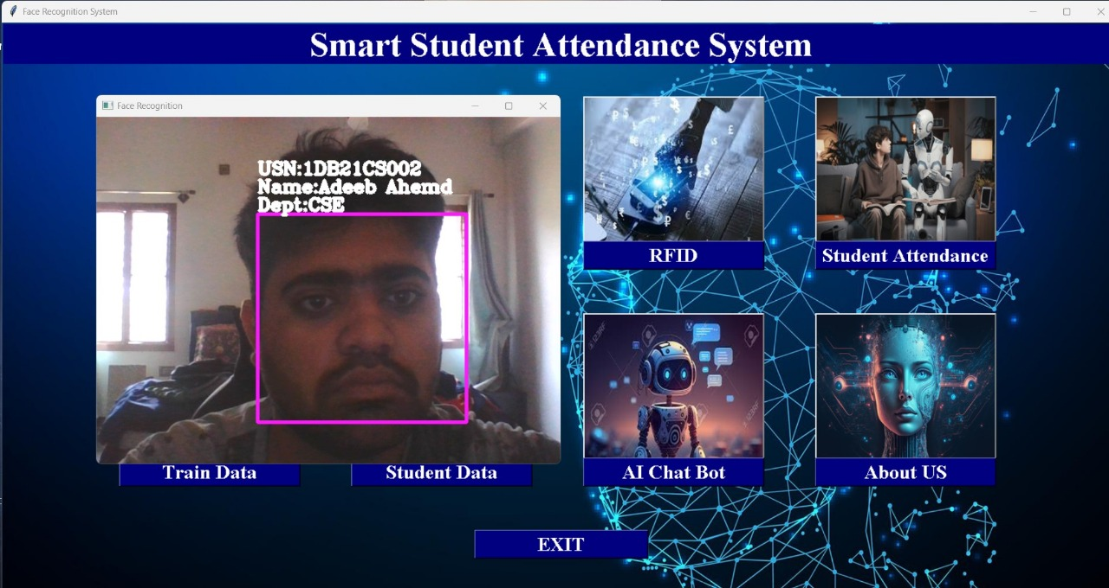
Fig 3.3 : The Student's Face Was Successfully Detected.
Fig 3.3 illustrates the use case diagram for the successful identification of a student's face within the attendance management system. This process begins with the real-time capture of the student's face by a camera. The captured image is then processed using sophisticated facial recognition algorithms. These algorithms analyze the image, extracting key facial features and comparing them against a database of pre-registered student facial data. If a match is found, the system verifies the student's identity, marking their attendance. This diagram provides a clear overview of the facial recognition component's role within the broader attendance management system. [3][6]
The verification phase ensures only authorized individuals are marked present by matching facial data and cross-checking with RFID information. The use case diagram highlights interactions between the user, system components, and functions, ensuring secure and accurate attendance.


Fig 3.4 : The Student's RFID card was successfully scanned
Fig 3.4 illustrates the use case diagram for the successful scanning of RFID cards in the attendance management system. In this process, the RFID scanner reads the unique data from the card presented by the user (student). This data is then verified against the records stored in the database to confirm the user's identity.
This step is crucial to ensure that the attendance recorded is accurate and corresponds to the authorized individual. The diagram highlights the interaction between the user, the RFID scanner, and the database, showcasing a seamless flow from scanning to authentication. This ensures a reliable and tamper-proof attendance management process.

CHAPTER 4
IMPLEMENTATION AND RESULTS
The below steps are going to explain about the implementation and results, and these processes include the following steps:
- User Registration
- Login Interface
- Main Page Functionality
- Student Management System
- Face Detection for Attendance
- RFID Card Scanning
- Recording Attendance in Excel

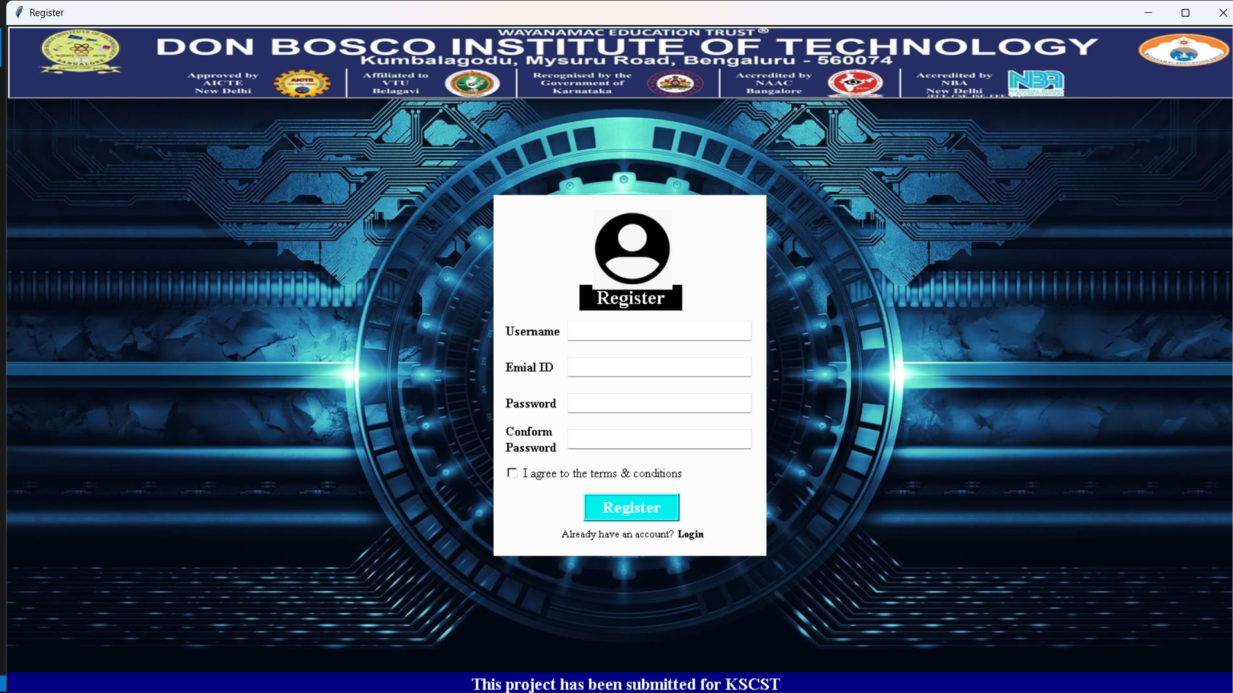
Fig 4.1: User Registration Interface
Fig 4.1 shows the Smart Attendance System's user registration window, where users enter their username, email ID, password, and confirm password. The system ensures that the user is successfully registered for future attendance monitoring by saving the data and displaying a confirmation message when the user completes the registration procedure.
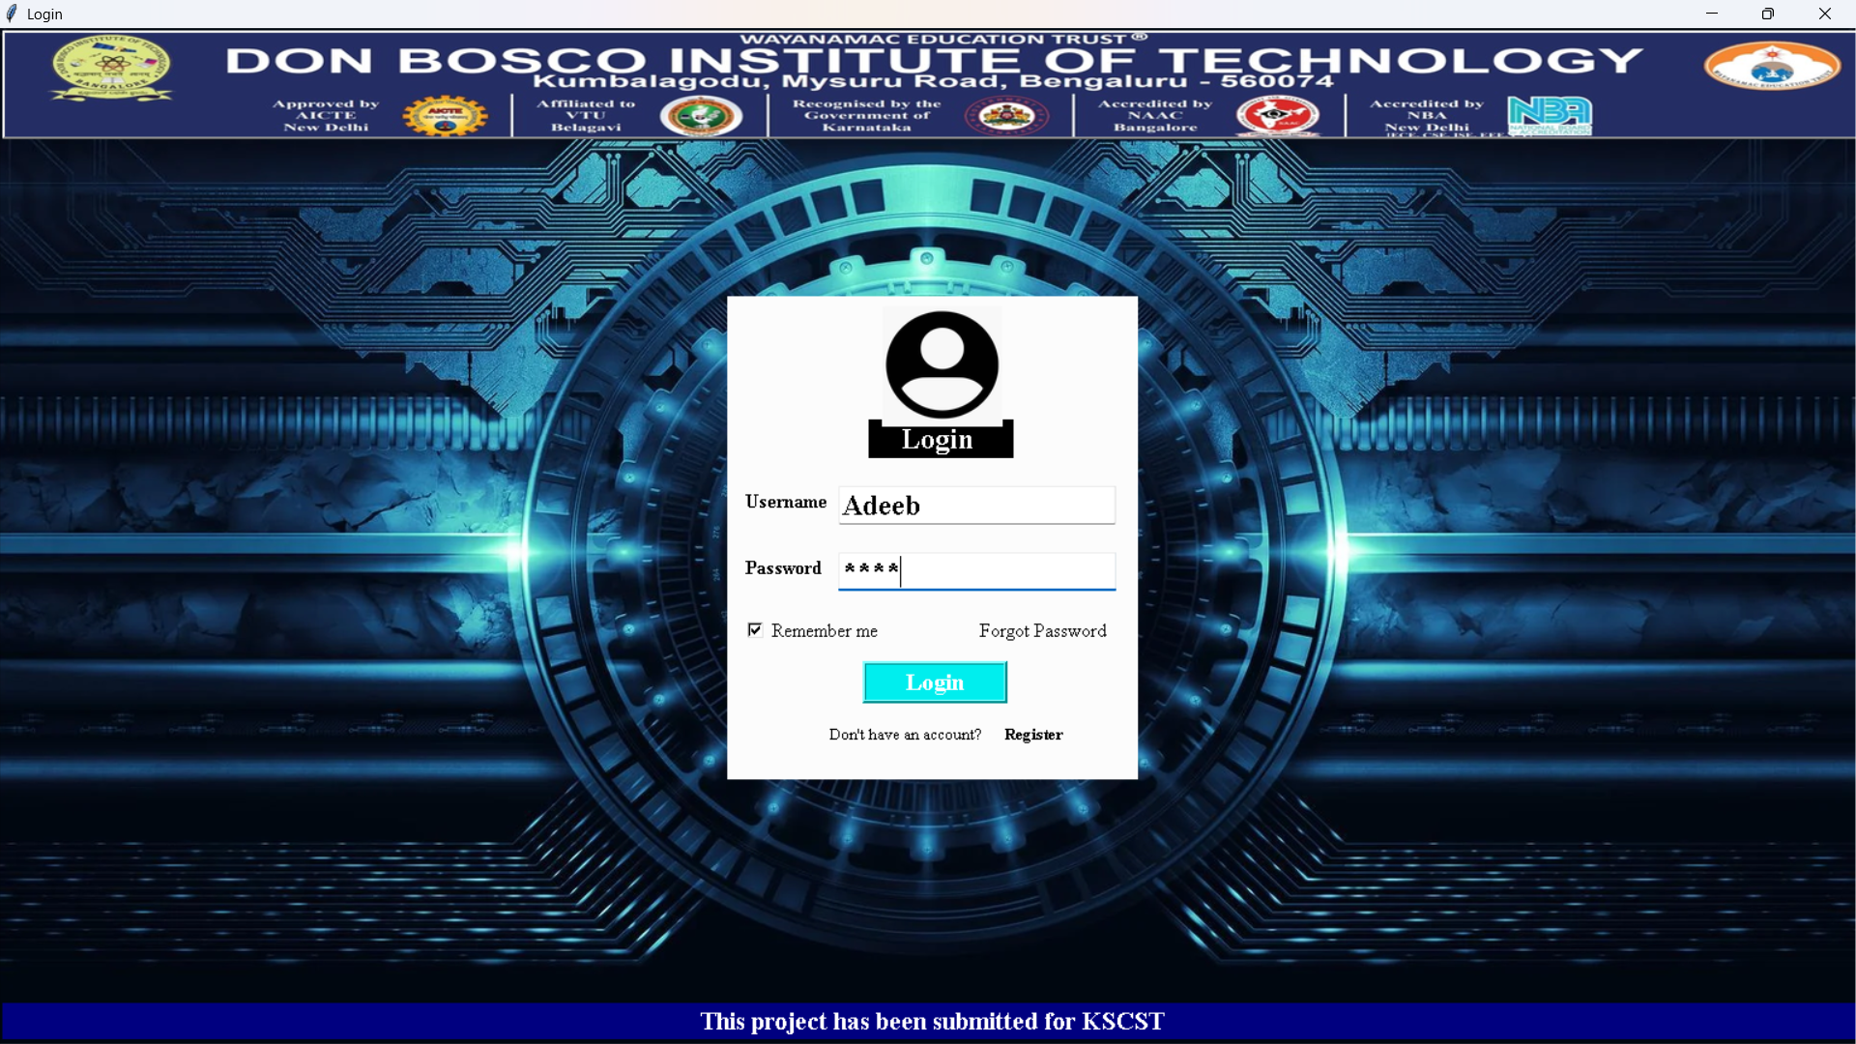
Fig 4.2: User Login Interface
Fig 4.2 shows the Smart Attendance System's user login screen is shown in this figure. To access the system, users must input their username and password. In the event that credentials are forgotten, the interface also offers choices for password recovery.
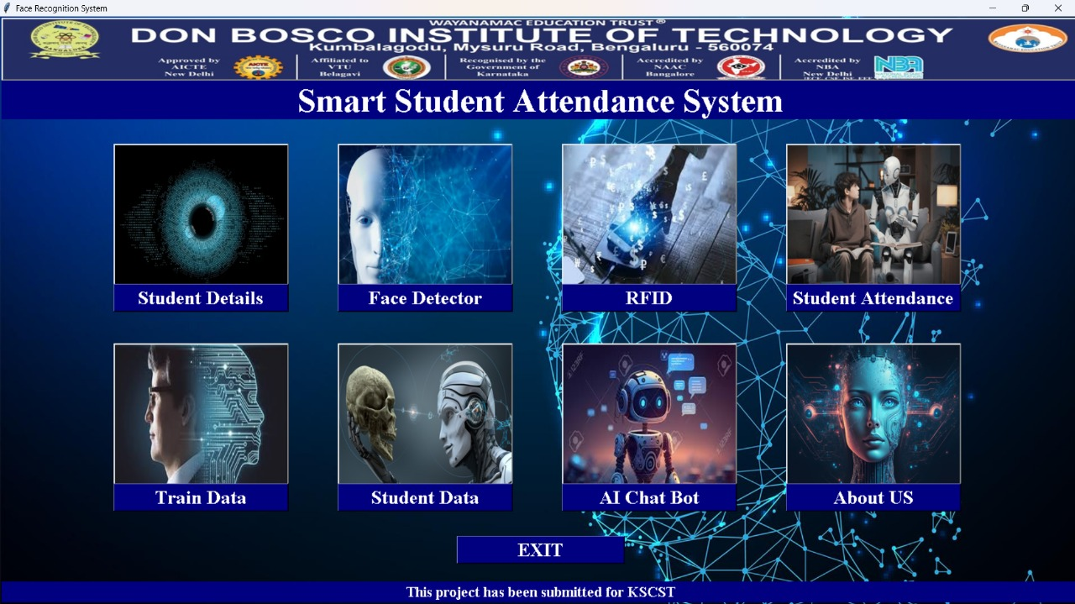
Fig 4.3: Main Dashboard Interface
Fig 4.3 shows the main dashboard of the Smart Attendance System, providing easy access to functions like recording attendance, managing records, and viewing reports. It offers a user-friendly interface for efficient navigation and secure data management.
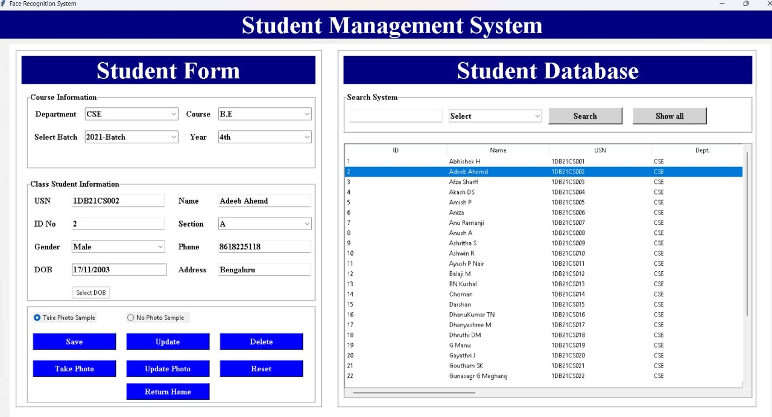
Fig 4.4: Student Management System Dashboard
Fig 4.4 shows the Smart Attendance System's main dashboard interface is depicted in this figure. From here, users can access a number of features, including maintaining student profiles, reading reports, and recording attendance.


Fig 4.5: Face Detection Successful
Fig 4.5 shows the confirmation of successful face detection, where the system successfully identifies and matches the user's face with the registered data for attendance verification.
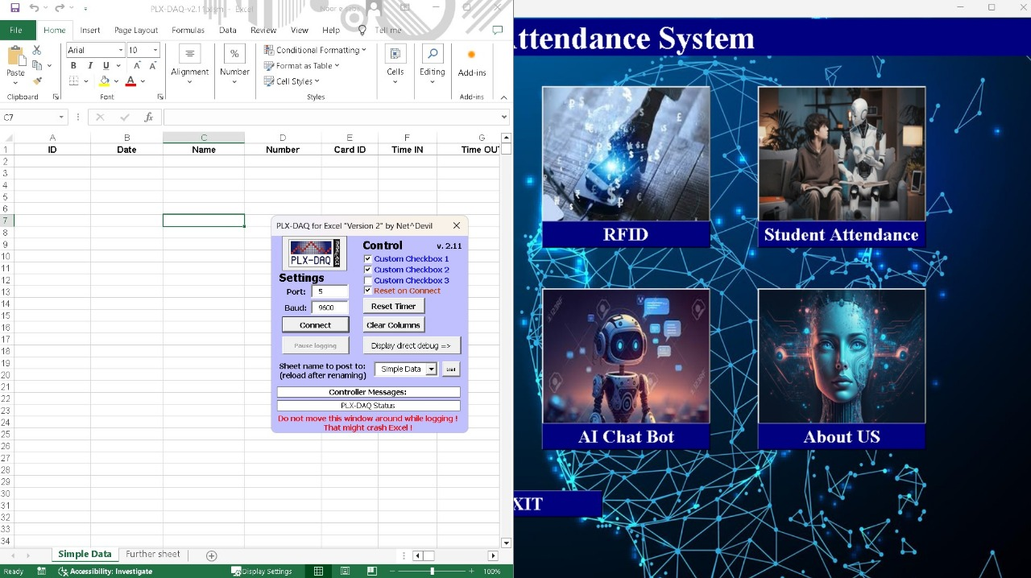
Fig 4.6: RFID Scanning Successful
Fig 4.6 shows the successful RFID card scan, the system successfully reads the card's unique ID and compares it with saved registration data.

Fig 4.7: Recording Attendance in Excel
Fig 4.7 shows the system successfully records attendance data in an Excel sheet depicted in this picture. Timestamped attendance and user information are automatically recorded for future usage.
CHAPTER 5
CONCLUSION
The suggested Smart Attendance System provides a thorough answer to the problems with conventional attendance management systems by combining RFID technology with facial detection. Conventional techniques like punch cards and manual roll calls are prone to fraud, mistakes, and inefficiency. By removing the necessity for physical touch and lowering the possibility of fraudulent activity, the incorporation of facial recognition technology offers a contactless, precise, and speedy way to record attendance. Combining this with RFID technology results in a supplementary layer of verification, which further improves security and dependability, particularly in settings like dim lighting or occlusions where facial recognition alone may not be reliable.
The system also addresses scalability and adaptability by leveraging Python’s programming capabilities, ensuring real-time processing, and using MySQL to securely manage and store attendance data. In addition to ensuring greater accuracy in person identification, the dual-layer verification approach streamlines attendance management, reducing errors and time.
Furthermore, the system’s user-friendly interface allows administrators to easily monitor and manage attendance records, while the integration of various hardware components such as RFID readers, cameras, and microcontrollers ensures seamless operation. The use of a centralized database ensures that the system remains organized and efficient, while also making it easier to access and update records as needed.
To sum up, the Smart Attendance System is a reliable, safe, and effective way to get around the drawbacks of conventional attendance systems. Assuring the accuracy and security of attendance management procedures while reducing manual labour and the potential for human error, its real-time facial recognition and RFID-based authentication offer a scalable, accurate, and user-friendly system appropriate for both corporate and educational settings.

REFERENCES
[1] Keerthana Sanath, Meenakshi K, Muktha Rajan, Varshini Balamurugan, and M.E. Harikumar, “RFID and Face Recognition based Smart Attendance System”, Fifth International Conference on Computing Methodologies and Communication (ICCMC 2021), IEEE Xplore Part Number: CFP21K25-ART.
[2] Bing-Zhong Jing, Patrick P. K. Chan, Wing W. Y. Ng, and Daniel S. Yeung, “Anti-Spoofing System for RFID Access Control Combining with Face Recognition”, Ninth International Conference on Machine Learning and Cybernetics, Qingdao, 11-14 July 2010 @ IEEE.
[3] Uppanapalli Lakshmi Sowjanya and R. Krithiga, “Facial Emotion Detection Model Using CNNs and Uniform Local Binary Pattern (uLBP) to analyze student behavior,” IEEE Access, Vol. 12, 2024.
[4] Dae-Hee Seo, Jang-Mi Baek and Mi-Yeon Yoon, “Improved Authentication Scheme using Facial Recognition scheme based on RFID Tag”, 2010 International Conference on Multimedia Information Networking and Security, Nanjing, China, 17 December 2010 @IEEE.
[5] Mingtao Zhao , Gang Zhao , and Meihong Qu, “College Smart Classroom Attendance Management System Based on Internet of Things”, Hindawi, Computational Intelligence and Neuroscience, Volume 2022, Article ID 4953721.
[6] Narayana Darapaneni, Aruna Kumari Evoori and Dhivakar Babu, “Automatic Face Detection and Recognition for Attendance Maintenance”, 15th (IEEE) International Conference on Industrial and Information Systems (ICIIS), 2020.

APPENDIX

Name | Abhishek H | Adeeb Ahmed | Balaji M | Dhanu Kumar T N
USN | 1DB21CS002 | 1DB21CS005 | 1DB21CS021 | 1DB21CS034
Phone No. | 6366274544 | 8618225118 | 9110288691 | 8971018716
Email | abhih601@gmail.com | zamadeebahmed@gmail.com | balajiraom2003@gmail.com | dhanukumartn2003@gmail.com
Placed in
Permanent Address | Kariramana Halli, Doddahulikunte Hobli Sira Tq, Tumkur dist - 572113 | #74, 8th cross, 3rd phase, judicial layout, Hejjala - 562109 | Mudimadagu (v&p), Srinivasapura Tq, Kolar dist - 563134 | Thuppadahalli (v&p) holalkere Tq chitradurga dist - 577539

